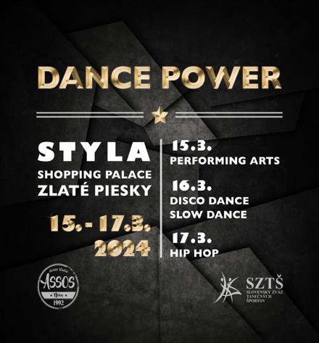PRIHLÁŠKA

Pre nečlenov SZTŠ sekcie IDO

DANCE Motion 2025

Tanečný klub: .............................................................................................................................................................

Meno a priezvisko vedúceho : ...................................................................................................................................

Tel., e-mail: ................................................................................................................................................................

**OPEN HIP HOP CHOREOGRAFIA**

(open choreografie, vlastná hudba max. 4 minúty, počet tanečníkov neobmedzene)

Názov.................................................... Veková kategória ( DVK, JVK, HVK).....................

Choreograf............................................

|  |  |  |
| --- | --- | --- |
|  | **Meno a priezvisko** | **Dátum narodenia** |
| 1 |  |  |
| 2 |  |  |
| 3 |  |  |
| 4 |  |  |
| 5 |  |  |
| 6 |  |  |
| 7 |  |  |
| 8 |  |  |
| 9 |  |  |
| 10 |  |  |
| 11 |  |  |
| 12 |  |  |
| 13 |  |  |
| 14 |  |  |
| 15 |  |  |
| 16 |  |  |
| 17 |  |  |
| 18 |  |  |
| 19 |  |  |
| 20 |  |  |
| 21 |  |  |
| 22 |  |  |
| 23 |  |  |
| 24 |  |  |

Vyplnenú prihlášku zaslať na [aura.tn@gmail.com](mailto:aura.tn@gmail.com) do 9.3.2025

DVK – deti rok nar.2013 a mladší/JVK – juniori rok nar. 2009 – 2012

HVK – dospelí rok narodenia 2008 a starší